Conversations+
MS Teams app installation

Devin Blagbrough 2024-01
Conversations+ Demo Environment MS Teams App installation steps.

Step 1
Save the file on this page for C1C+ for MS Teams App to your local computer:

- Download link available Here
- C1C+MSTeams_app_demo_env.zip

Step 2
Select “Apps” from the tiles on the left side bar of MS Teams

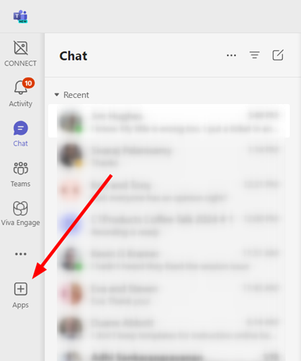

Step 3
Then choose “Manage your apps” from the bottom of the App menu

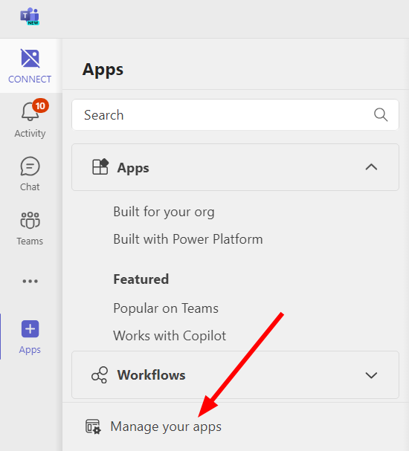

Step 4
Then select “Upload an App”

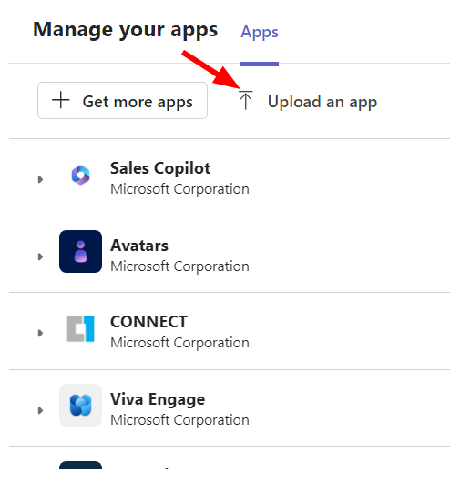

Step 5
Choose “Upload a custom app”

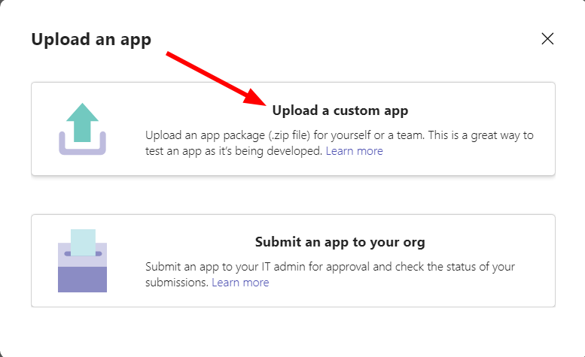

Step 6
Browse to the file folder where you saved the file and then select the file you saved in step 1.

Step 7
Click “Add” to finish adding the app.

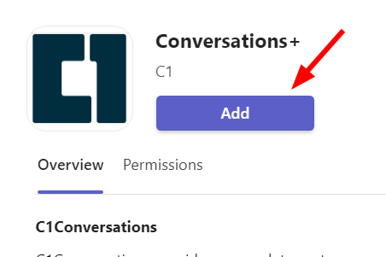

Step 8
The first time you use this app, it will require permissions to use the microphone.

